Grocery Sales Analytics System

Project Overview
The Grocery Sales Analytics System is designed to analyse retail transaction data from a mid-sized grocery chain operating across 10 Indian cities. The system automates data cleaning, performs exploratory data analysis (EDA), and generates actionable insights for business decision-making. Using Python and Power BI, the project transforms raw sales data into structured reports and dashboards that highlight revenue trends, customer behaviour, store performance, and discount impact.
Objectives:
- To clean and validate raw grocery transaction data
- To identify and fix data quality issues (missing values, duplicates, outliers)
- To perform exploratory data analysis across multiple dimensions (time, city, category, customer)
- To answer 8 critical business problems using structured analytics
- To build interactive Power BI dashboards for executive reporting
- To improve decision-making in pricing, promotions, and store operations
System Overview:
The Grocery Sales Analytics System processes a dataset of 10,000 transactions across 15 columns. It applies systematic data cleaning, feature engineering, and statistical analysis to generate insights. The workflow includes:
- Data Cleaning – Removing duplicates, handling missing values, validating numeric ranges
- Outlier Detection – Identifying anomalies in quantity, unit price, and transaction amounts
- Feature Engineering – Creating derived metrics such as gross revenue, discount amount, mismatch flags, seasonality indices
- Business Problem Analysis – Addressing eight predefined problems (discount leakage, seasonal trends, regional gaps, customer behaviour, payment adoption, product mix, store performance, data quality)
- Dashboard Reporting – Visualizing KPIs, trends, and comparisons in Power BI

Modules / Features:
- Data Cleaning Module
  - Removes duplicates and null values
  - Validates transaction integrity (quantity > 0, price > 0, discount between 0–80%)
- Outlier Detection Module
  - Uses IQR method to flag anomalies in sales data
  - Marks suspicious transactions for review
- Feature Engineering Module
  - Calculates gross revenue, discount impact, mismatch flags
  - Extracts time-based features (month, quarter, week)
  - Builds seasonality indices for category-level analysis
- Business Problem Analysis Module
  - Executes Python functions for each of the 8 problems
  - Generates category, city, region, and customer-level insights
- Dashboard Module
  - Power BI dashboards with KPIs, charts, and slicers
  - Tabs: Overview, Discount & Customer Insights, Store Performance

Dataset Design:
File: Grocery_Store_Sales_Dataset.csv
- Rows: 10,000 transactions
- Columns: 15 (Transaction_ID, Date, Customer_ID, Age Group, City, Region, Store_ID, Category, Product_Name, Brand, Quantity, Unit Price, Discount %, Total Amount, Payment Method)
- Period: Jan–Dec 2023
- Scope: 10 cities, 4 regions, 100 products across 10 categories

Analytical Problems:
- Revenue Leakage via Discounts – Identify categories with high discounts and measure revenue loss.
- Seasonal Sales Fluctuations – Detect peak/trough months and seasonal categories.
- City & Regional Performance Gap – Compare revenue and transactions across cities/regions.
- Customer Age Group Behaviour – Analyze spending patterns and category preferences by age group.
- Payment Method Adoption – Track digital vs cash payment trends.
- Product & Category Mix Analysis – Perform Pareto analysis, identify top/slow-moving products.
- Store-Level Performance – Rank top/bottom 10 stores, compare against city averages.
- Data Quality & Completeness – Validate integrity: missing values, duplicates, outliers, mismatches.

Outputs:
- Cleaned Dataset – Exported as cleaned_grocery_data.csv
- KPIs – Revenue, Transactions, Avg Transaction Value, Quantity Sold, Discount Impact
- Reports – Monthly/Quarterly Sales, Category Seasonality, City/Region Revenue, Customer Insights
- Dashboards – Interactive Power BI visuals with filters for Month, City, Age Group, Store

Overview Report:
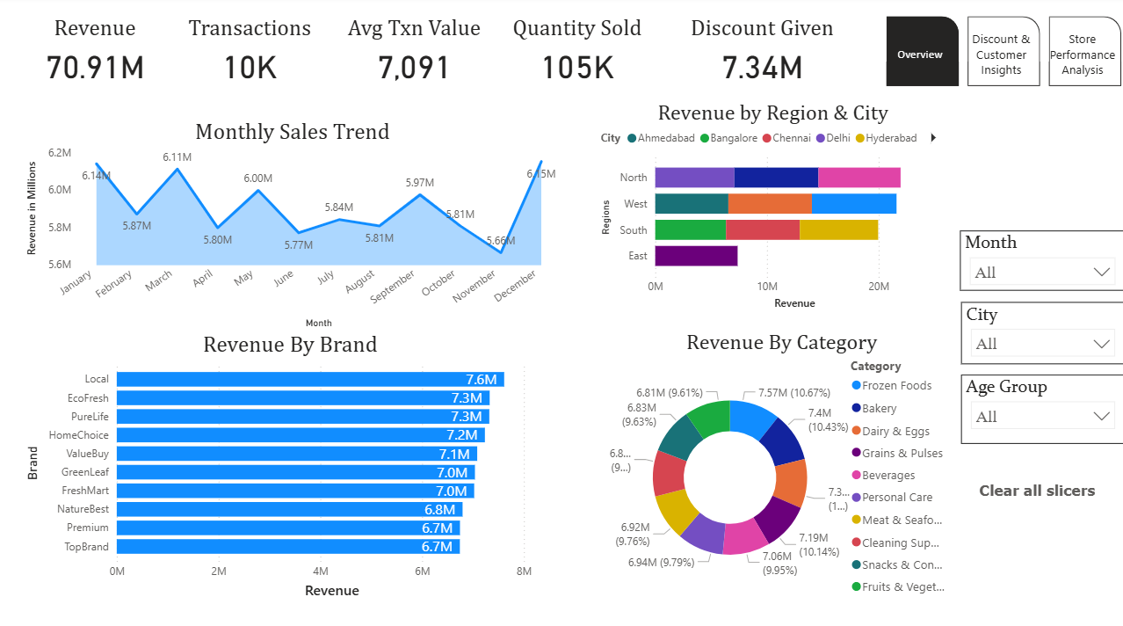

Discount and Customer Insights:

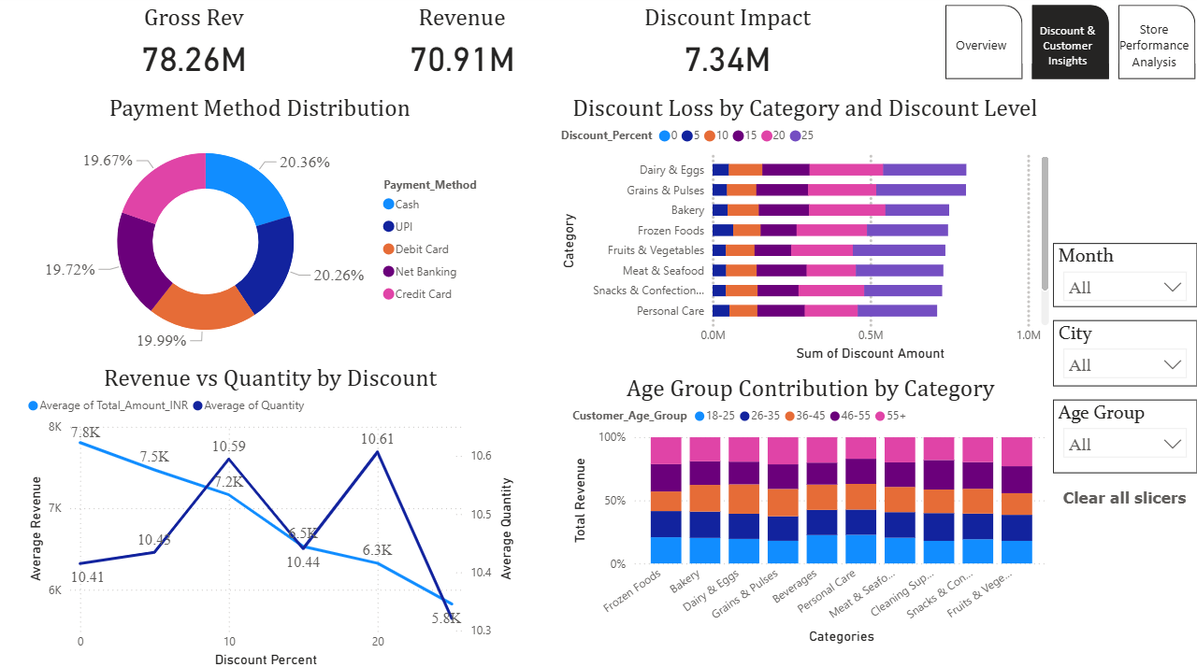

Store Performance Analysis:
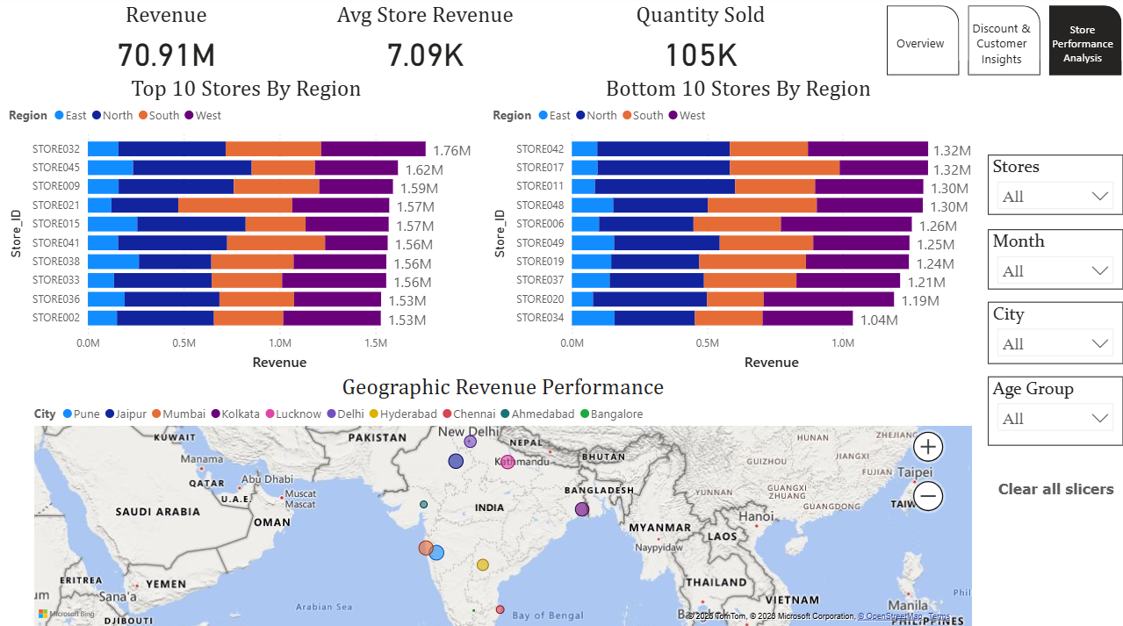

Technologies Used:
- Programming Language: Python (pandas, NumPy)
- Environment: Jupyter Notebook
- Visualization Tool: Power BI (DAX measures, slicers, drill-through, map visuals)
- Database Format: CSV dataset (10,000 × 15)

Future Enhancements:
- Real-time integration with POS systems
- Predictive modelling for demand forecasting
- Customer segmentation for targeted promotions
- Automated anomaly detection using ML models
- Cloud deployment for scalability

Conclusion:
The Grocery Sales Analytics System successfully transforms raw transaction data into actionable insights. By combining Python-based data cleaning and Power BI dashboards, the project enables evidence-based decision-making in pricing, promotions, and store operations. It provides a scalable framework for retail analytics, ensuring improved profitability and customer satisfaction.

